21. FOURIER Analysis of Fold Shapes
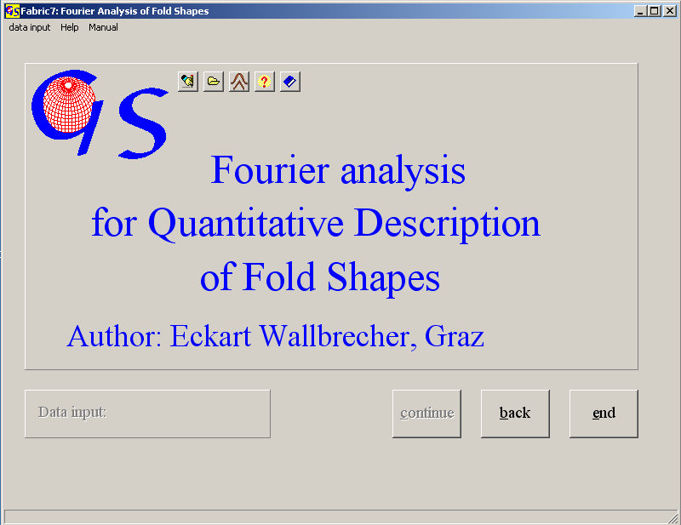
Fig. 1

This program (Fig. 1) describes the shape of a fold by Fourier-coeffifients (RAMSAY & HUBER, 1987:314ff.). The profile of a fold is regarded as a harmonic wave which can be decomposed into its harmonic components by Fourier analysis. The general formula for description of an arbitrary harmonic wave with Fourier coefficients is

f(xy) = a₀ + a₁cos α + a₂cos 2α + a₃cos 3α + .......
+ b₁sin α + b₂sin 2α + b₃sin 3α + .......

For the description of the profile of a tectonic fold the number of coefficients reduces to max. three. The reasons are:
1. The profile can always begin in the inversion point. if we put this point in the zero point of the coordinate system, a₀ and all cosine terms become 0.
2. Assuming that the fold is symmetrical, we only look at a quarter fold (i. e. the profile between inversion and hinge) in this case all terms with even indices become 0.
3. For a sufficiently exact description of the fold shape we only need the first thre coefficients.

b₁, b₃ und b₅.
For the calculation of these coefficients we need three points on the quarter fold. With the inversion ar x=0 and y=0, three points of the quarte fold are measured with x- and y-values in integer numbers. The third of these points must be the hinge of the fold. The shape is represented by a point in a diagram with b1 and b3 as coordinates. b5 can be neglected. The form for manual input is shown in Fig. 2. A vergency of the fold can be eliminated by back shearing. For this we need the angle of vergency. The extension for data files is “.FOU”. Since only ratios are calculated, the scale of coordinates is arbitrary.

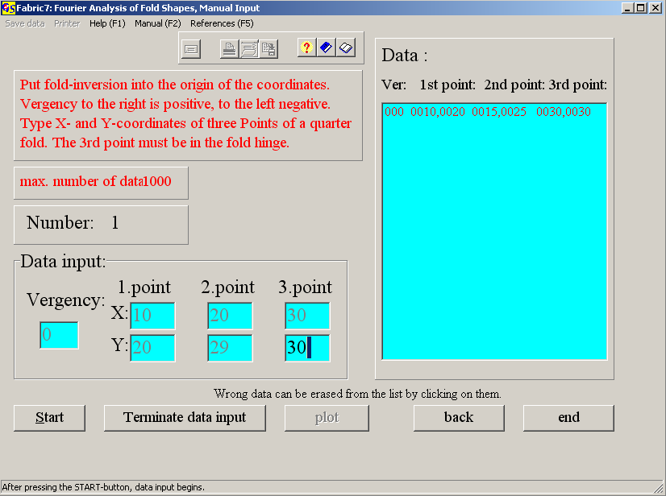Fig. 2

Input from a file is the same as in all other programs.

Data input from a picture:
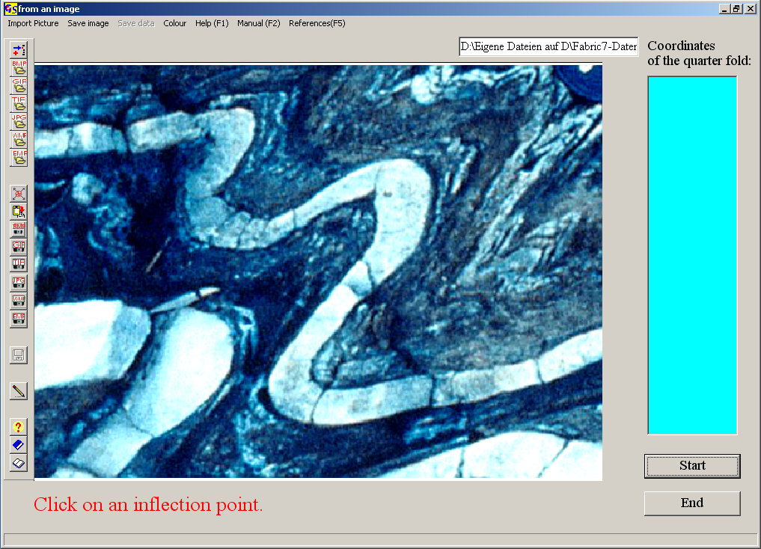
Fig. 2

Create a *.BMP, *.GIF, *.TIF, *.JPG, *.WMF or *.EMF file from the picture which contains the fold profile. Import the image with "Import picture" to the graphic surface (Fig. 2).
Click on two inflection points of the same folded surface to rotate the fold into a horizontal position. After clicking on the second point, the image rotates until both inflection points lie on a horizontal line (Fig. 3). In order to eliminate vergency, click on two points of the axial plane. The fold is upwright now (Fig. 4).
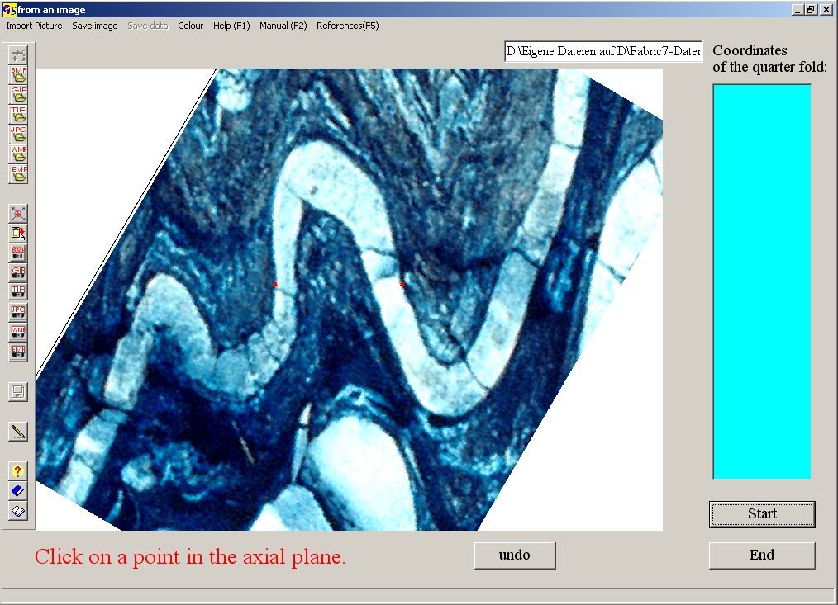
Fig. 3

The image can be rotated and/or the vergency can be eliminated. Two inflection points should lie on a horizontal line after rotation ton. Then click on one inflection point and then on the second. The image rotates around the centre (Fig. 3);
In order to eliminate the vergency, click on 'eliminate vergency' in the menu 'adjust picture'. Then click on two points in the axial plane of the fold. The fold will be upright (Fig. 4).
In order to find the coordinates of the quarter fold, click on the inflection point and then on the hinge point. Now click on the 1/3 and 2/3 coordinates (Fig. 5).
Fig. 6 shows the graphic form. The list on the right side show the calculated coefficients b1, b2, and b3. The red dots give the b1/b3 ratios of the folds. The lines are:

F = chevron folds
D = parabolic folds
C = semi ellipses
A = box folds.

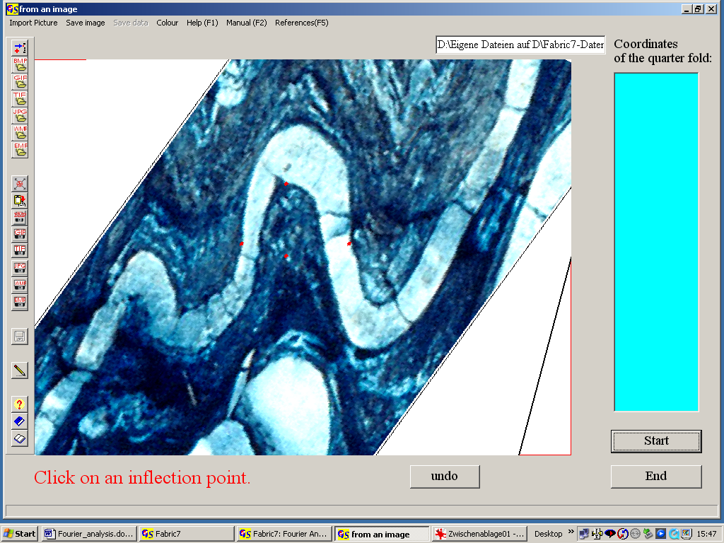
Fig. 4
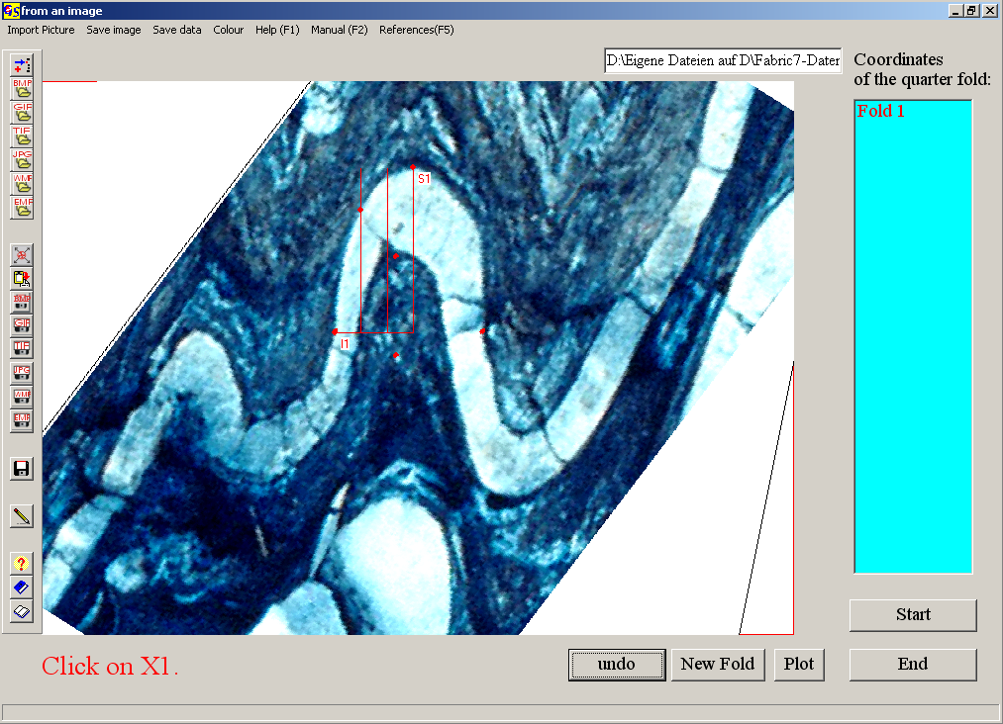Fig. 5

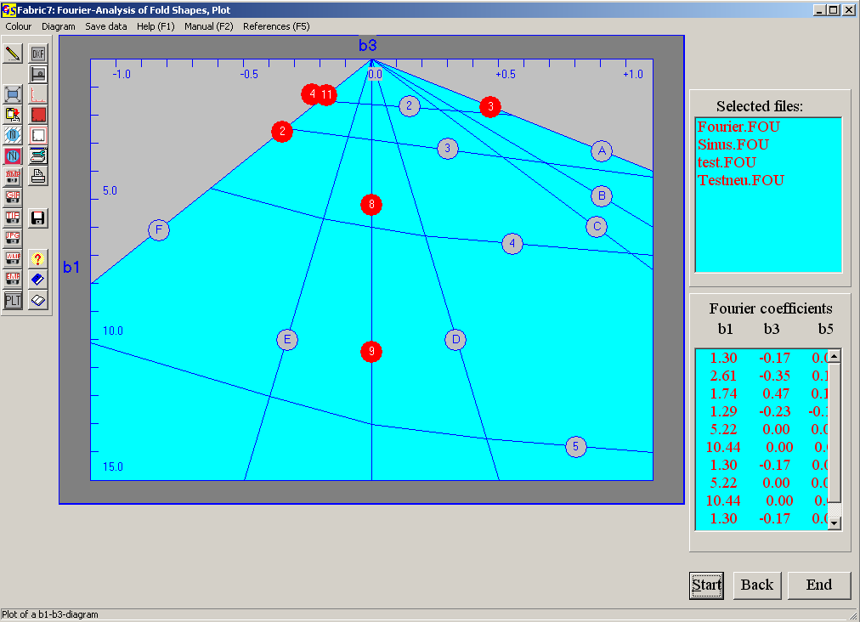
Fig. 6

The numbered lines show increasing amplitudes (HUDDLESTON, 1973).

The options of the menu "Diagram" are explained in program 3.

